

**SIMATS SCHOOL OF ENGINEERING**

**SAVEETHA INSTITUTE OF MEDICAL AND TECHNICAL SCIENCES**

**CHENNAI-602105**

**Railway Reservation System**

**A CAPSTONE PROJECT REPORT**

*Submitted in the partial fulfillment for the award of the degree of*

**BACHELOR OF ENGINEERING**

**IN**

**Computer Science and Engineering**

**Submitted by**

**Jaswanth Varma S (192211389)**

**Saikrishna G (192211779)**

**Under the Supervision of**

**Ms.B. Jeevashri**

**JULY 2024**

**DECLARATION**

We, **Jaswanth Varma S, Saikrishna G** students of **Bachelor of Engineering in CSE**, Department of Computer Science and Engineering, Saveetha Institute of Medical and Technical Sciences, Saveetha University, Chennai, hereby declare that the work presented in this Capstone Project Work entitled **Railway Reservation System** is the outcome of our own bonafide work and is correct to the best of our knowledge and this work has been undertaken taking care of Engineering Ethics.

**Jaswanth Varma S** **(192211389)**

**Saikrishna G (192211779)**

Date: 31/07/2024

Place: Chennai

**CERTIFICATE**

This is to certify that the project entitled **“Railway Reservation System”** submitted by **Jaswanth Varma S ,Saikrishna G** has been carried out under my supervision. The project has been submitted as per the requirements in the current semester of B.E. Computer Science Engineering.

Teacher-in-charge

Ms.B.Jeevashri

**Table of Contents**

|  |  |
| --- | --- |
| **S.NO** | **TOPICS** |
|  | **Abstract** |
| 1 | **Introduction** |
| 2 | **Project Description** |
| 3 | **Problem Description** |
| 4 | **Tool Description** |
| 5 | **Operations** |
| 6 | **Approach / Module Description / Functionalities** 6.1 User **Authentication Module** **6.2 Reservation Management Module**  **6.3 Ticket Booking Module**  **6.4 Payment Module.** |
| 7 | **Implementation** |
| 8 | **Result** |
| 9 | **Conclusion** |
|  | **References** |

**ABSTRACT**

“The Railway Reservation System” is an innovative web-based application designed to streamline the process of booking train tickets, ensuring a seamless experience for users. This system offers real-time access to train schedules, availability of seats, and fare information, allowing passengers to plan their journeys efficiently. Users can create accounts, search for trains, make reservations, and cancel bookings with ease. The system supports various payment methods, ensuring secure and convenient transactions. It also provides features such as seat selection, meal preferences, and special assistance requests. Additionally, the platform is equipped with an intuitive user interface and responsive design, making it accessible on both desktop and mobile devices.

By leveraging advanced technologies, the Railway Reservation System aims to reduce the time and effort involved in ticket booking, enhance customer satisfaction, and improve the overall efficiency of railway operations. It also includes administrative functionalities for railway staff to manage train schedules, monitor booking statuses, and generate reports. This comprehensive solution is designed to cater to the needs of both passengers and railway authorities, ensuring a smooth and hassle-free travel experience.

1. **INTRODUCTION**

The Railway Reservation System, a cutting-edge web application designed to revolutionize the way passengers book train tickets. This platform provides a comprehensive solution for all your railway travel needs, offering a user-friendly interface that simplifies the process of searching, booking, and managing train reservations. With real-time access to train schedules, seat availability, and fare information, passengers can plan their journeys with precision and convenience. The system allows users to create personal accounts, which enable a streamlined booking process and personalized travel experiences. Features such as seat selection, meal preferences, and special assistance requests cater to individual needs, ensuring a comfortable journey for all passengers.

“ The Railway Reservation System” is equipped with robust security measures to protect user data and ensure secure transactions through various payment methods. Its responsive design guarantees seamless access on both desktop and mobile devices, making it easy for users to book tickets on the go. For railway authorities, the platform offers powerful administrative tools to manage train schedules, monitor booking statuses, and generate insightful reports, enhancing operational efficiency.

This innovative system aims to reduce the time and effort involved in traditional ticket booking, minimize queues at railway stations, and provide a hassle-free travel experience. By leveraging the latest in web technologies, the Railway Reservation System not only improves customer satisfaction but also supports the modernization of railway operations. Whether you are a frequent traveller or planning a special trip, our system is designed to meet all your railway travel needs with ease and efficiency. Experience the future of railway reservations with our advanced, user-centric platform. These features collectively offer significant benefits, such as convenience, time-saving, accessibility, and an enhanced user experience. Passengers can book tickets from the comfort of their homes or on the go, without the need to visit a railway station. The system reduces the time spent on booking tickets and managing reservations, streamlining the entire process. It is accessible 24/7, allowing users to book tickets at any time that suits them. With features like real-time updates and secure transactions, the system enhances the overall user experience. The Online Railway Reservation System is a significant advancement in the railway service sector, providing passengers with a reliable, efficient, and user-friendly platform for booking train tickets. By integrating modern web technologies and ensuring robust security measures, the system aims to deliver a superior travel experience, making railway journeys more accessible and enjoyable for all passengers.

1. **PROJECT DESCRIPTION**

“The Railway Reservation System” is a web application developed to enhance the efficiency and convenience of booking train tickets.

#### Proposed Method

* **Frontend Development**: Utilizing Visual Studio for designing responsive and intuitive user interfaces.
* **Backend Development**: Using XAMPP stack (Apache, MySQL, PHP) to handle server-side scripting, database management via phpMyAdmin, and ensuring secure data storage and retrieval.

**2.1 About my project**

#### Purpose and Scope

The Railway Reservation System is a user-friendly web application that streamlines train ticket booking, offering real-time schedules, seat availability, and secure transactions for a hassle-free travel experience.

#### Features and Functionality

* **User Accounts**: Allows passengers to create and manage personal accounts for a streamlined booking experience.
* **Ticket Booking**: Enables easy reservation of train tickets with seat selection options.
* **Payment Gateway**: Supports multiple secure payment methods for convenient transactions.
* **Security**: Implements robust measures to protect user data and ensure transaction security.

1. **Problem Description**

**Existing Method**

Railway reservation involve a combination of physical ticket counters, travel agents, official railway websites, mobile applications, the Unreserved Ticketing System (UTS), Tatkal booking, and special quota booking. Traditionally, passengers visit railway station counters where booking clerks manually check train schedules and seat availability, and tickets are printed after payments are made. Travel agents also facilitate bookings by accessing railway reservation systems, often charging an additional service fee. Online booking through official railway websites and mobile applications has become increasingly popular, allowing passengers to register, search for trains, check seat availability, and make payments using various methods. E-tickets are then generated and sent to the user's email or phone. The UTS caters to short-distance and suburban train passengers by offering unreserved tickets without seat reservations. Tatkal booking is available for last-minute travel needs, where a quota of tickets can be booked online or at counters a day before the journey. Additionally, special quotas for senior citizens, differently-abled persons, and other categories are available both online and at railway counters, requiring relevant ID proofs. Despite the availability of these methods, challenges such as long queues, dependency on travel agents, and occasional website or app downtimes persist, highlighting the need for a more streamlined and user-friendly railway reservation system.

1. **Tool Description**

#### Hardware and Software Tools

To develop and deploy the railway reservation system web application, the following hardware and software tools were utilized:

**Hardware Specifications**

* **Laptop Model**: ASUS ROG Strix
* **Graphics Card**: NVIDIA GeForce RTX 3060, 4GB
* **Storage**: 1TB SSD
* **RAM**: 16GB
* **Processor**: AMD Ryzen 7 6800H

The ASUS ROG Strix laptop with its high-performance specifications provided an excellent environment for developing and testing the web application. The NVIDIA GeForce RTX 3060 graphics card ensured smooth rendering of graphics and multimedia content, enhancing the development experience, especially when dealing with high-resolution recipe images and user interface design. The 1TB SSD facilitated fast data read/write operations, significantly reducing load times for development tools and ensuring rapid access to project files. With 16GB of RAM, the laptop efficiently handled multiple development tools running concurrently, supporting a seamless multitasking environment. The AMD Ryzen 7 6800H processor, known for its powerful performance and energy efficiency, enabled quick compilation and execution of code, speeding up the development cycle.

**Software Tools**

* **Visual Studio Code**: An integrated development environment (IDE) used for writing and debugging code. Its extensions and integrated terminal enhanced the coding experience.
* **XAMPP**: A free and open-source cross-platform web server solution stack package developed by Apache Friends. It provided the necessary Apache, MySQL, PHP, and Perl support for local development and testing.
* **phpMyAdmin**: A free software tool written in PHP, intended to handle the administration of MySQL over the web. phpMyAdmin was used for database management, allowing for easy handling of the MySQL database used in the application.
* **GitHub**: Used for version control and collaborative development. The repository hosted the project's source code, enabling team collaboration and version tracking.
* **Google Chrome**: The primary web browser used for testing and debugging the web application. Developer tools in Chrome facilitated real-time inspection and modification of the front-end code.

The combination of powerful hardware and a robust set of development tools provided a conducive environment for the efficient development, testing, and deployment of the recipe management web application.

**5. OPERATIONS**

The Railway Reservation System enables users to search for trains, check availability, book tickets, and manage reservations seamlessly online. Below are the detailed operations based on the provided code and functionalities of the application:

#### 5.1 Administrator Operations

**Creating and Managing System**

* **Train Schedule Management**: Add, update, and remove train schedules and routes.
* **Seat Allocation**: Define and update seat layouts for different classes. Set seat quotas for categories like Tatkal, senior citizens, and differently-abled passengers.

**Managing Categories**

* **Travel Class Management**:Define and manage different travel classes (e.g., sleeper, AC, general).Update fare structures for each travel class.
* **Special Quotas Management**:Manage categories for special quotas such as Tatkal, senior citizens, and differently-abled passengers.Allocate seats and monitor availability for each quota category.

**User Management**

* **Account Management**:Create, update, and delete user accounts.Assign roles and permissions to users.
* **User Support**: Assist users with account-related issues, such as password resets and account recovery. Handle user complaints and feedback.

**Analyzing Usage**

* **Usage Statistics**: Monitor user engagement and system usage statistics. Track key performance indicators (KPIs) such as the number of bookings, cancellations, and user sign-ups.
* **Performance Monitoring**: Assess the performance of the system in terms of speed, reliability, and user satisfaction. Implement improvements based on usage analysis and feedback.

#### 5.2 User Operations

**Interacting with the System**

* **Account Registration and Login**: Create a new user account with secure registration. Log in to the system using a username and password.
* **Profile Management**: Update personal information such as name, contact details, and address. Change account settings and preferences, including password updates.

**Searching and Booking Trains**

* **Train Search**: Search for trains based on destination, departure time, and travel date. View train schedules, routes, and seat availability in real-time.
* **Ticket Booking**: Provide passenger details and confirm booking. Make payments using various secure payment methods (credit/debit cards, net banking, digital wallets). Receive booking confirmation via email or SMS.
* **Booking Management**: View and manage existing bookings, including travel details and seat assignments. Modify bookings, such as changing travel dates or seats .

**Payments and Transactions**

* **Payment Management**: Make secure payments for ticket bookings. View transaction history and download payment receipts. Resolve payment issues with customer support if needed.

**Security and Compliance**

* **Account Security**: Reset passwords and recover account access securely. Enable two-factor authentication for enhanced security. Monitor account activity for any unauthorized access.

These user operations ensure a smooth, convenient, and secure experience for passengers booking and managing their railway journeys.

* + 1. **APPROACH / MODULE DESCRIPTION / FUNCTIONALITIES**

To develop the Railway reservation system Application, we will divide the project into distinct modules, each responsible for specific functionalities. By creating individual functions for every operation and unifying them, we can ensure modularity, maintainability, and scalability.

#### Modules and Functionalities

### **6.1 User Authentication Module**

**Function: Register User**

* **Description:** Allows new users to create an account.
* **Functionalities:**
  + Collect user information (username, password).
  + Validate and store user information in the database.

**Function: Login User**

* **Description:** Authenticates existing users.
* **Functionalities:**
  + Verify user credentials (username and password).
  + Start a session for the authenticated user.

### **6.2 Reservation Management Module (Administrator)**

**Function: Book now**

* **Description:** Allows administrators to book new ticket.
* **Functionalities:**
  + Input reservation details (name, gender, phn no, no of tickets).
  + Save the details to the database.

**Function: About us**

* **Description:** Enables Users to contact with developers.
* **Functionalities:**
  + Input the details your name, email, message.
  + save changes.

### **6.3 Ticket Booking Module (User)**

**Function: Booking**

* **Description:** Allows users to Book tickets.
* **Functionalities:**
  + Fetching the details of customer (name, gender, phone no, no of tickets).

**Function: Passenger Details**

* **Description:** Allow users to enter the passenger details.

### **6.4 Payment Module (User)**

**Function: Pay now**

* **Description:** Displays total amount of price that user want to pay.
* **Functionalities:**
  + User can pay by using UPI ID or with credit Card.

**Function: Ticket Confirmation Details**

* **Description:** Displays all the details about the ticket to the user.

**7. IMPLEMENTATION**

**Register page**

<!DOCTYPE html>

<html lang="en">

<head>

<meta charset="UTF-8">

<meta name="viewport" content="width=device-width, initial-scale=1.0">

<title>Register Page</title>

<style>

body {

font-family: Arial, sans-serif;

background-image: url("image3.jpg"); /* Replace with your image URL */

background-size: cover;

background-repeat: repeat;

display: flex;

justify-content: center;

align-items: center;

height: 100vh;

margin: 0;

}

.register-container {

background-color: rgba(255, 255, 224, 0.9); /* Light yellow with transparency */

padding: 30px;

border-radius: 10px;

box-shadow: 0 0 15px rgba(0, 0, 0, 0.2);

max-width: 400px;

width: 100%;

}

.register-container h2 {

margin-bottom: 25px;

color: #333333;

text-align: center;

}

.register-container label {

display: block;

margin-bottom: 8px;

color: #333333;

font-weight: bold;

}

.register-container input[type="text"],

.register-container input[type="password"] {

width: 100%;

padding: 12px;

margin-bottom: 20px;

border: 1px solid #dddddd;

border-radius: 5px;

box-sizing: border-box;

font-size: 16px;

background-color: #fffaf0; /* Ivory background for inputs */

color: #333333; /* Dark text color */

}

.register-container button {

width: 100%;

padding: 12px;

background-color: #f7d05f; /* Light yellow */

border: none;

border-radius: 5px;

color: #333333;

font-size: 18px;

cursor: pointer;

transition: background-color 0.3s;

}

.register-container button:hover {

background-color: #f4c542; /* Darker yellow */

}

.login-link {

display: block;

margin-top: 20px;

text-align: center;

color: #333333;

text-decoration: none;

font-size: 16px;

}

.login-link:hover {

color: #f7d05f; /* Light yellow */

}

</style>

</head>

<body>

<div class="register-container">

<h2>Register</h2>

<form action="p1.html" method="POST">

<label for="username">Username:</label>

<input type="text" id="username" name="username" required>

<label for="new_password">New Password:</label>

<input type="password" id="new_password" name="new_password" required>

<label for="confirm_password">Confirm Password:</label>

<input type="password" id="confirm_password" name="confirm_password" required>

<button type="submit">Register</button>

</form>

</div>

</body>

</html>

Login page

<!DOCTYPE html>

<html lang="en">

<head>

<meta charset="UTF-8">

<meta name="viewport" content="width=device-width, initial-scale=1.0">

<title>Login Page</title>

<style>

body {

font-family: Arial, sans-serif;

background-image: url("image 2.jpg");

background-size: cover;

background-repeat: no-repeat;

background-attachment: fixed;

display: flex;

justify-content: center;

align-items: center;

height: 100vh;

margin: 0;

}

.login-container {

background-color: rgba(173, 216, 230, 0.9); /* Light blue with transparency */

padding: 30px;

border-radius: 10px;

box-shadow: 0 0 15px rgba(0, 0, 0, 0.2);

max-width: 400px;

width: 100%;

}

.login-container h2 {

margin-bottom: 25px;

color: #333333;

text-align: center;

}

.login-container label {

display: block;

margin-bottom: 8px;

color: #333333;

font-weight: bold;

}

.login-container input[type="text"],

.login-container input[type="password"] {

width: 100%;

padding: 12px;

margin-bottom: 20px;

border: 1px solid #dddddd;

border-radius: 5px;

box-sizing: border-box;

font-size: 16px;

background-color: #f0f8ff; /* Alice blue background for inputs */

color: #333333; /* Dark text color */

}

.login-container button {

width: 100%;

padding: 12px;

background-color: #87CEEB; /* Sky blue */

border: none;

border-radius: 5px;

color: white;

font-size: 18px;

cursor: pointer;

transition: background-color 0.3s;

}

.login-container button:hover {

background-color: #00BFFF; /* Deep sky blue */

}

.register-link {

display: block;

margin-top: 20px;

text-align: center;

color: #333333;

text-decoration: none;

font-size: 16px;

}

.register-link:hover {

color: #0000CD; /* Medium blue */

}

</style>

</head>

<body>

<div class="login-container">

<h2>Login</h2>

<form action="h1.html" method="POST">

<label for="username">Username:</label>

<input type="text" id="username" name="username" required>

<label for="password">Password:</label>

<input type="password" id="password" name="password" required>

<button type="submit">Login</button>

</form>

<a href="p2.html" class="register-link">Register</a>

</div>

</body>

</html>

**Home Page**

<!DOCTYPE html>

<html lang="en">

<head>

<meta charset="UTF-8" />

<meta http-equiv="X-UA-Compatible" content="IE=edge" />

<meta name="viewport" content="width=device-width, initial-scale=1.0" />

<title>Railway Ticket Booking</title>

<style>

/* Add custom styles here for the railway ticket booking homepage */

body {

font-family: Arial, sans-serif;

margin: 0;

padding: 0;

box-sizing: border-box;

}

.navbar {

background-color: #333;

color: #fff;

padding: 10px 0;

position: fixed;

width: 100%;

top: 0;

left: 0;

z-index: 1000;

}

.navbar-container {

display: flex;

justify-content: space-between;

align-items: center;

padding: 0 20px;

}

.navbar .logo {

font-size: 24px;

font-weight: bold;

}

.menu-items {

list-style: none;

margin: 0;

padding: 0;

display: flex;

}

.menu-items li {

margin: 0 15px;

}

.menu-items a {

color: #fff;

text-decoration: none;

}

.showcase-area {

background-image: url("image 0.jpg");

background-size: cover; /* Ensures the image covers the area */

background-repeat: no-repeat; /* Prevents the image from repeating */

background-position: center center; /* Centers the background image */

color: #fff;

text-align: center;

padding: 100px 20px;

height: 100vh;

position: relative; /* Ensures that the height is respected */

overflow: hidden; /* Prevents overflow issues */

}

.showcase-container {

max-width: 600px;

margin: 0 auto;

}

.showcase-area h1 {

font-size: 48px;

margin-bottom: 20px;

}

.showcase-area p {

font-size: 18px;

margin-bottom: 30px;

}

.btn-primary {

background-color: #ff5722;

color: #fff;

padding: 10px 20px;

text-decoration: none;

border-radius: 5px;

}

section {

padding: 60px 20px;

}

.container {

max-width: 1200px;

margin: 0 auto;

}

.food-container {

display: flex;

justify-content: space-between;

flex-wrap: wrap;

}

.food-type {

width: 30%;

margin-bottom: 20px;

}

.food-type img {

width: 100%;

height: auto;

border-radius: 10px;

}

.food-menu-container {

display: flex;

flex-wrap: wrap;

gap: 20px;

}

.food-menu-item {

width: 30%;

border: 1px solid #ddd;

border-radius: 10px;

overflow: hidden;

box-shadow: 0 2px 5px rgba(0, 0, 0, 0.1);

}

.food-menu-item img {

width: 100%;

height: auto;

}

.food-description {

padding: 15px;

}

.food-price {

font-weight: bold;

color: #ff5722;

}

.testimonial-container {

display: flex;

flex-direction: column;

gap: 20px;

}

.testimonial-box {

border: 1px solid #ddd;

border-radius: 10px;

padding: 20px;

background: #f9f9f9;

}

.testimonial-box .customer-photo {

display: flex;

align-items: center;

gap: 10px;

}

.testimonial-box img {

border-radius: 50%;

width: 50px;

height: 50px;

}

.star-rating .fa-star {

color: #ff5722;

}

.contact-container {

display: flex;

align-items: center;

gap: 20px;

}

.contact-img img {

width: 100%;

height: auto;

border-radius: 10px;

}

.form-container {

width: 100%;

max-width: 600px;

}

.form-container input, .form-container textarea {

width: 100%;

padding: 10px;

margin-bottom: 10px;

border: 1px solid #ddd;

border-radius: 5px;

}

.footer {

background-color: #333;

color: #fff;

text-align: center;

padding: 20px 0;

}

@media (max-width: 768px) {

.food-type, .food-menu-item {

width: 100%;

}

.food-container, .food-menu-container {

flex-direction: column;

}

.contact-container {

flex-direction: column;

}

}

html {

scroll-behavior: smooth;

}

</style>

</head>

<body>

<nav class="navbar">

<div class="navbar-container container">

<h1 class="logo">Railway</h1>

<ul class="menu-items">

<li><a href="h2.html">About Us</a></li>

<li><a href="p1.html">Logout</a></li>

</ul>

</div>

</nav>

<section class="showcase-area" id="home">

<div class="showcase-container">

<h1 class="main-title">Welcome to Railway Booking</h1>

<p>Efficient and convenient ticket booking at your fingertips.</p>

<a href="p4.html" class="btn btn-primary">Book Now</a>

</div>

</section>

<!-- Removed "Book Ticket" section -->

<!-- Removed "Contact Us" section -->

<footer class="footer">

<h2>Railway Ticket Booking &copy; 2024 All Rights Reserved</h2>

</footer>

</body>

</html>

**About us**

<!DOCTYPE html>

<html lang="en">

<head>

<meta charset="UTF-8" />

<meta http-equiv="X-UA-Compatible" content="IE=edge" />

<meta name="viewport" content="width=device-width, initial-scale=1.0" />

<title>About Us</title>

<link rel="stylesheet" href="https://cdnjs.cloudflare.com/ajax/libs/font-awesome/5.15.3/css/all.min.css"

integrity="sha512-iBBXm8fW90+nuLcSKlbmrPcLa0OT92xO1BIsZ+ywDWZCvqsWgccV3gFoRBv0z+8dLJgyAHIhR35VZc2oM/gI1w=="

crossorigin="anonymous" referrerpolicy="no-referrer" />

<link rel="stylesheet" href="style.css" />

<style>

/* Add custom styles here for the About Us page */

.about-container {

max-width: 1200px;

margin: 0 auto;

padding: 20px;

text-align: center;

}

.about-container h1 {

font-size: 36px;

margin-bottom: 20px;

}

.about-container p {

font-size: 18px;

margin-bottom: 40px;

}

.about-form-container {

max-width: 600px;

margin: 0 auto;

padding: 20px;

background: #f9f9f9;

border-radius: 10px;

box-shadow: 0 4px 8px rgba(0, 0, 0, 0.1);

}

.about-form-container h2 {

font-size: 28px;

margin-bottom: 20px;

color: #333;

}

.about-form-container label {

display: block;

margin-bottom: 5px;

font-weight: bold;

}

.about-form-container input,

.about-form-container textarea {

width: calc(100% - 20px);

padding: 10px;

margin-bottom: 15px;

border: 1px solid #ddd;

border-radius: 5px;

font-size: 16px;

box-sizing: border-box;

}

.about-form-container textarea {

resize: vertical;

}

.about-form-container button {

background-color: #ff5722;

color: #fff;

padding: 10px 20px;

border: none;

border-radius: 5px;

cursor: pointer;

font-size: 16px;

transition: background-color 0.3s ease;

}

.about-form-container button:hover {

background-color: #e64a19;

}

.footer {

background-color: #333;

color: #fff;

text-align: center;

padding: 20px 0;

}

</style>

</head>

<body>

<nav class="navbar">

<div class="navbar-container container">

<h1 class="logo">Railway</h1>

<ul class="menu-items">

<li><a href="h2.html">About Us</a></li>

<li><a href="p1.html">Logout</a></li>

</ul>

</div>

</nav>

<section class="about-container">

<h1>About Us</h1>

<p>Providing the best railway booking service for over 10 years. Our commitment is to ensure a smooth and hassle-free experience for every traveler.</p>

<div class="about-form-container">

<h2>Contact Us</h2>

<form action="#" method="post">

<label for="name">Your Name:</label>

<input type="text" id="name" name="name" required />

<label for="email">E-Mail:</label>

<input type="email" id="email" name="email" required />

<label for="message">Type Your Message:</label>

<textarea id="message" name="message" cols="30" rows="6" required></textarea>

<button type="submit">Submit</button>

</form>

</div>

</section>

<footer class="footer">

<h2>Railway Ticket Booking &copy; 2024 All Rights Reserved</h2>

</footer>

</body>

</html>

**Booking Page**

<!DOCTYPE html>

<html lang="en">

<head>

<meta charset="UTF-8">

<meta name="viewport" content="width=device-width, initial-scale=1.0">

<title>Railway Booking Form</title>

<style>

body {

font-family: Arial, sans-serif;

background-image: url("image 7.jpg");

background-size: cover;

background-repeat: no-repeat;

background-position: center;

margin: 0;

padding: 0;

display: flex;

justify-content: center;

align-items: center;

height: 100vh;

background-color: #e9ecef;

}

.container {

background-color: rgba(255, 255, 255, 0.9);

padding: 20px;

border-radius: 10px;

box-shadow: 0 4px 8px rgba(0, 0, 0, 0.1);

width: 350px;

max-height: 90vh;

overflow-y: auto;

}

h2 {

text-align: center;

margin-bottom: 20px;

color: #007bff;

}

label {

display: block;

margin-bottom: 5px;

font-weight: bold;

color: #007bff;

}

input, select {

width: 100%;

padding: 10px;

margin-bottom: 15px;

border: 1px solid #ccc;

border-radius: 5px;

font-size: 1em;

box-sizing: border-box;

transition: border-color 0.3s;

}

input:focus, select:focus {

border-color: #007bff;

outline: none;

}

.note {

font-size: 0.9em;

color: #777;

margin-bottom: 20px;

text-align: center;

}

.button {

display: flex;

justify-content: center;

}

button {

padding: 10px 20px;

background-color: #007bff;

color: #fff;

border: none;

border-radius: 5px;

cursor: pointer;

font-size: 1em;

transition: background-color 0.3s;

}

button:hover {

background-color: #0056b3;

}

.passenger-form {

margin-top: 20px;

}

.passenger-form h3 {

color: #007bff;

}

</style>

</head>

<body>

<div class="container" id="initial-form-container">

<h2>Railway Booking Form</h2>

<form id="initial-form">

<label for="name">Name:</label>

<input type="text" id="name" name="name" required>

<label for="gender">Gender:</label>

<select id="gender" name="gender" required>

<option value="">Select Gender</option>

<option value="male">Male</option>

<option value="female">Female</option>

<option value="other">Other</option>

</select>

<label for="phone">Phone Number:</label>

<input type="tel" id="phone" name="phone" pattern="[0-9]{10}" required>

<label for="tickets">Number of Railway Tickets:</label>

<input type="number" id="tickets" name="tickets" min="1" max="6" required>

<div class="note">Note: Maximum a person can book up to 6 tickets.</div>

<div class="button">

<button type="button" onclick="generateTicketForm()">Next</button>

</div>

</form>

</div>

<div class="container" id="ticket-form-container" style="display: none;">

<h2>Passenger Details</h2>

<form id="ticket-form" onsubmit="handleSubmit(event)">

<div id="passenger-forms"></div>

<div class="button">

<button type="submit">Submit</button>

</div>

</form>

</div>

<script>

function generateTicketForm() {

const tickets = document.getElementById('tickets').value;

const passengerFormsContainer = document.getElementById('passenger-forms');

passengerFormsContainer.innerHTML = '';

for (let i = 1; i <= tickets; i++) {

const passengerForm = document.createElement('div');

passengerForm.className = 'passenger-form';

passengerForm.innerHTML = `

<h3>Passenger ${i}</h3>

<label for="passenger-name-${i}">Name:</label>

<input type="text" id="passenger-name-${i}" name="passenger-name-${i}" required>

<label for="passenger-phone-${i}">Phone Number:</label>

<input type="tel" id="passenger-phone-${i}" name="passenger-phone-${i}" pattern="[0-9]{10}" required>

<label for="passenger-gender-${i}">Gender:</label>

<select id="passenger-gender-${i}" name="passenger-gender-${i}" required>

<option value="">Select Gender</option>

<option value="male">Male</option>

<option value="female">Female</option>

<option value="other">Other</option>

</select>

<label for="from-station-${i}">From Station:</label>

<input type="text" id="from-station-${i}" name="from-station-${i}" required>

<label for="to-station-${i}">To Station:</label>

<input type="text" id="to-station-${i}" name="to-station-${i}" required>

<label for="date-${i}">Date:</label>

<input type="date" id="date-${i}" name="date-${i}" required>

<label for="departure-time-${i}">Departure Time:</label>

<input type="time" id="departure-time-${i}" name="departure-time-${i}" required>

<label for="class-${i}">Class:</label>

<select id="class-${i}" name="class-${i}" required>

<option value="">Select Class</option>

<option value="sleeper">Sleeper</option>

<option value="ac">AC</option>

<option value="first-class">First Class</option>

</select>

`;

passengerFormsContainer.appendChild(passengerForm);

}

document.getElementById('initial-form-container').style.display = 'none';

document.getElementById('ticket-form-container').style.display = 'block';

}

function handleSubmit(event) {

event.preventDefault();

const tickets = document.getElementById('tickets').value;

localStorage.setItem('ticketsBooked', tickets);

for (let i = 1; i <= tickets; i++) {

localStorage.setItem(`passenger-name-${i}`, document.getElementById(`passenger-name-${i}`).value);

localStorage.setItem(`passenger-phone-${i}`, document.getElementById(`passenger-phone-${i}`).value);

localStorage.setItem(`passenger-gender-${i}`, document.getElementById(`passenger-gender-${i}`).value);

localStorage.setItem(`from-station-${i}`, document.getElementById(`from-station-${i}`).value);

localStorage.setItem(`to-station-${i}`, document.getElementById(`to-station-${i}`).value);

localStorage.setItem(`date-${i}`, document.getElementById(`date-${i}`).value);

localStorage.setItem(`departure-time-${i}`, document.getElementById(`departure-time-${i}`).value);

localStorage.setItem(`class-${i}`, document.getElementById(`class-${i}`).value);

// Generate a random seat number and store it

const seat = `Seat ${Math.floor(Math.random() * 100) + 1}`;

localStorage.setItem(`seat-${i}`, seat);

}

window.location.href = 'p7.html';

}

</script>

</body>

</html>

**Payment Form**

<!DOCTYPE html>

<html lang="en">

<head>

<meta charset="UTF-8">

<meta name="viewport" content="width=device-width, initial-scale=1.0">

<title>Payment Form</title>

<style>

body {

font-family: Arial, sans-serif;

background-image: url("image 5.jpg");

background-size: cover;

background-repeat: no-repeat;

background-position: center;

margin: 0;

padding: 0;

display: flex;

justify-content: center;

align-items: center;

height: 100vh;

background-color: #e9ecef;

}

.container {

background-color: rgba(255, 255, 255, 0.9);

padding: 20px;

border-radius: 10px;

box-shadow: 0 4px 8px rgba(0, 0, 0, 0.1);

width: 350px;

}

h2 {

text-align: center;

margin-bottom: 20px;

color: #007bff;

}

label {

display: block;

margin-bottom: 5px;

font-weight: bold;

color: #007bff;

}

input, select {

width: 100%;

padding: 10px;

margin-bottom: 15px;

border: 1px solid #ccc;

border-radius: 5px;

font-size: 1em;

box-sizing: border-box;

transition: border-color 0.3s;

}

input:focus, select:focus {

border-color: #007bff;

outline: none;

}

.note {

font-size: 0.9em;

color: #777;

margin-bottom: 20px;

text-align: center;

}

.button {

display: flex;

justify-content: center;

}

button {

padding: 10px 20px;

background-color: #007bff;

color: #fff;

border: none;

border-radius: 5px;

cursor: pointer;

font-size: 1em;

transition: background-color 0.3s;

}

button:hover {

background-color: #0056b3;

}

.total-price {

text-align: center;

font-size: 1.2em;

margin-bottom: 20px;

color: #007bff;

}

.payment-details {

display: none;

}

</style>

</head>

<body>

<div class="container">

<h2>Payment Form</h2>

<form id="payment-form">

<div class="note">

<label for="tickets">Number of Tickets Booked:</label>

<input type="number" id="tickets" name="tickets" value="0" readonly>

</div>

<div class="total-price">

Total Price: <span id="total-price">0</span> Rupees

</div>

<label for="payment-method">Payment Method:</label>

<select id="payment-method" name="payment-method" required>

<option value="">Select Payment Method</option>

<option value="upi">UPI</option>

<option value="credit-card">Credit Card</option>

</select>

<div id="upi-details" class="payment-details">

<label for="upi-id">UPI ID:</label>

<input type="text" id="upi-id" name="upi-id" placeholder="example@upi">

</div>

<div id="credit-card-details" class="payment-details">

<label for="card-number">Card Number:</label>

<input type="text" id="card-number" name="card-number" pattern="\d{16}" placeholder="1234 5678 9012 3456">

<label for="expiry-date">Expiry Date:</label>

<input type="month" id="expiry-date" name="expiry-date">

<label for="cvv">CVV:</label>

<input type="text" id="cvv" name="cvv" pattern="\d{3}" placeholder="123">

</div>

<div class="button">

<button type="submit">Pay Now</button>

</div>

</form>

</div>

<script>

const classMultipliers = {

'sleeper': 0.50,

'ac': 2.00,

'first-class': 3.50

};

const distances = {

'Hyderabad-Vishakhapatnam': 512.87,

'Vijayawada-Warangal': 198.09,

'Guntur-Nellore': 213.92,

'Kukatpalli-Nizamabad': 135.34,

'Rajahmundry-Kakinada': 46.42,

'Tirupati-Anantapur': 227.06,

'Karimnagar-Machilipatnam': 328.39,

'Eluru-Vizianagaram': 291.93,

'Proddatur-Ongole': 182.19,

'Khammam-Nandyal': 264.95,

'Adoni-Bhimavaram': 464.94,

'Upal-Mahbubnagar': 97.05,

'Hindupur-Cuddapah': 159.33,

'Nalgonda-Guntakal': 290.38,

'Adilabad-Srikakulam': 584.33,

'Gudivada-Dharmavaram': 415.74,

'Suriapet-Madanapalle': 417.80,

'Tadepallegudem-Mirialguda': 204.00,

'Jagtial-Narasaraopet': 307.94,

'Chilakalurupet-Tadpatri': 264.37,

'Chirala-Anakapalle': 351.68,

'Kavali-Kadiri': 214.82,

'Rayachoti-Nirmal': 563.12,

'Emmiganuru-Kottagudem': 391.66,

'Mancheral-Paloncha': 193.03,

'Gudur-Bodhan': 545.26,

'Sirsilla-Kamareddi': 51.54,

'Bapatla-Tanuku': 162.02,

'Palasa-Siddipet': 591.83,

'Markapur-Tandur': 246.31,

'Vinukonda-Koratla': 326.57,

'Rayadrug-Mangalagiri': 439.06,

'Narasapur-Sangareddi': 402.03,

'Kodar-Palakollu': 194.63,

'Ponnuru-Gadwal': 296.06,

'Wanparti-Samalkot': 444.93,

'Kandukur-Sattenapalle': 134.63,

'Nuzvid-Bobbili': 332.26,

'Pithapuram-Amalapuram': 65.00,

'Tuni-Parvatipuram': 184.71,

'Macherla-Salur': 461.38,

'Bhongir-Punganuru': 461.95,

'Mandapeta-Jangaon': 306.86,

'Patancheru-Zahirabad': 70.76,

'Bhaisa-Peddapuram': 494.15,

'Nayudupeta-Bhadrachalam': 431.82,

'Parlakimidi-Nandikotkur': 696.47,

'Bhimunipatnam-Medak': 546.73,

'Nidadavole-Jammalamadugu': 419.16,

'Yellandu-Vikarabad': 259.78

};

const ticketsBooked = parseInt(localStorage.getItem('ticketsBooked')) || 0;

document.getElementById('tickets').value = ticketsBooked;

let totalPrice = 0;

for (let i = 1; i <= ticketsBooked; i++) {

const travelClass = localStorage.getItem(`class-${i}`);

const fromPlace = localStorage.getItem(`from-station-${i}`);

const toPlace = localStorage.getItem(`to-station-${i}`);

const route = `${fromPlace}-${toPlace}`;

const distance = distances[route] || 0;

const price = distance * classMultipliers[travelClass];

totalPrice += price;

}

document.getElementById('total-price').innerText = totalPrice.toFixed(2);

document.getElementById('payment-method').addEventListener('change', function() {

const paymentMethod = this.value;

document.getElementById('upi-id').required = paymentMethod === 'upi';

document.getElementById('card-number').required = paymentMethod === 'credit-card';

document.getElementById('expiry-date').required = paymentMethod === 'credit-card';

document.getElementById('cvv').required = paymentMethod === 'credit-card';

document.getElementById('upi-details').style.display = paymentMethod === 'upi' ? 'block' : 'none';

document.getElementById('credit-card-details').style.display = paymentMethod === 'credit-card' ? 'block' : 'none';

});

document.getElementById('payment-form').addEventListener('submit', function(event) {

event.preventDefault();

alert('Payment Successful!');

// Redirect to p8.html to show ticket and passenger details

window.location.href = 'p8.html';

});

</script>

</body>

</html>

**Ticket Confirmation form**

<!DOCTYPE html>

<html lang="en">

<head>

<meta charset="UTF-8">

<meta name="viewport" content="width=device-width, initial-scale=1.0">

<title>Ticket and Passenger Details</title>

<style>

body {

font-family: Arial, sans-serif;

background-image: url("image 5.jpg");

background-size: cover;

background-repeat: no-repeat;

background-position: center;

margin: 0;

padding: 0;

display: flex;

justify-content: center;

align-items: center;

height: 100vh;

background-color: #e9ecef;

}

.container {

background-color: rgba(255, 255, 255, 0.9);

padding: 20px;

border-radius: 10px;

box-shadow: 0 4px 8px rgba(0, 0, 0, 0.1);

width: 350px;

overflow-y: auto;

max-height: 90vh;

}

h2 {

text-align: center;

margin-bottom: 20px;

color: #007bff;

}

.details {

margin-bottom: 20px;

}

.details label {

font-weight: bold;

color: #007bff;

}

.details div {

margin-bottom: 10px;

}

.button {

display: flex;

justify-content: center;

}

button {

padding: 10px 20px;

background-color: #007bff;

color: #fff;

border: none;

border-radius: 5px;

cursor: pointer;

font-size: 1em;

transition: background-color 0.3s;

}

button:hover {

background-color: #0056b3;

}

.passenger {

margin-bottom: 20px;

padding: 10px;

background-color: rgba(0, 123, 255, 0.1);

border-radius: 5px;

}

.passenger h3 {

margin: 0;

margin-bottom: 10px;

color: #0056b3;

}

</style>

</head>

<body>

<div class="container">

<h2>Ticket and Passenger Details</h2>

<div class="details">

<div id="ticket-details"></div>

<div id="passenger-details"></div>

</div>

<div class="button">

<button onclick="goBack()">Go Back</button>

</div>

</div>

<script>

function generateRandomSeat() {

return `Seat ${Math.floor(Math.random() * 100) + 1}`;

}

function displayDetails() {

const ticketsBooked = parseInt(localStorage.getItem('ticketsBooked')) || 0;

const ticketDetails = document.getElementById('ticket-details');

const passengerDetails = document.getElementById('passenger-details');

ticketDetails.innerHTML = `<label>Number of Tickets:</label><div>${ticketsBooked}</div>`;

const passengers = [];

for (let i = 1; i <= ticketsBooked; i++) {

const name = localStorage.getItem(`passenger-name-${i}`);

const phone = localStorage.getItem(`passenger-phone-${i}`);

const gender = localStorage.getItem(`passenger-gender-${i}`);

const fromStation = localStorage.getItem(`from-station-${i}`);

const toStation = localStorage.getItem(`to-station-${i}`);

const date = localStorage.getItem(`date-${i}`);

const departureTime = localStorage.getItem(`departure-time-${i}`);

const travelClass = localStorage.getItem(`class-${i}`);

let seat = localStorage.getItem(`seat-${i}`);

if (!seat) {

seat = generateRandomSeat();

localStorage.setItem(`seat-${i}`, seat);

}

passengers.push({

name, phone, gender, fromStation, toStation, date, departureTime, travelClass, seat

});

}

let passengerHtml = '<label>Passenger Details:</label>';

passengers.forEach((p, index) => {

passengerHtml += `

<div class="passenger">

<h3>Passenger ${index + 1}</h3>

<div>Name: ${p.name}</div>

<div>Phone: ${p.phone}</div>

<div>Gender: ${p.gender}</div>

<div>From Station: ${p.fromStation}</div>

<div>To Station: ${p.toStation}</div>

<div>Date: ${p.date}</div>

<div>Departure Time: ${p.departureTime}</div>

<div>Class: ${p.travelClass}</div>

<div>Seat: ${p.seat}</div>

</div>

`;

});

passengerDetails.innerHTML = passengerHtml;

}

function goBack() {

window.location.href = 'p1.html'; // Go back to the previous form

}

// Display the details on page load

displayDetails();

</script>

</body>

</html>

**8.SCREENSHOTS**

**8.1Register page:**

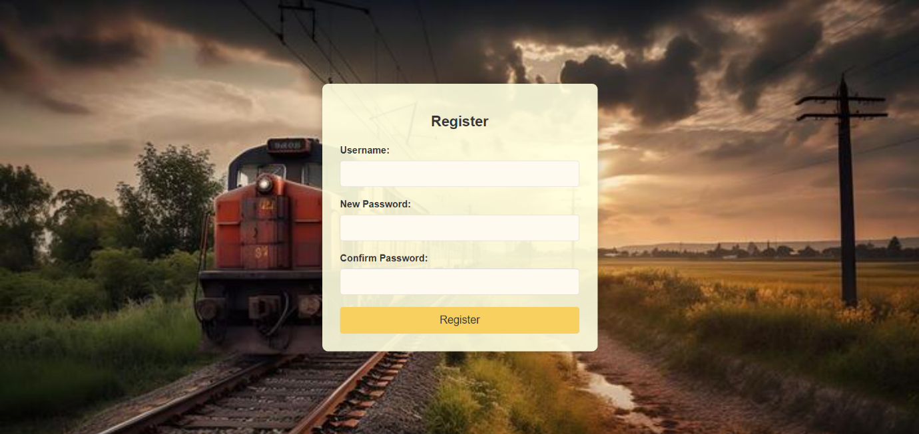

**8.2 Login Page:**

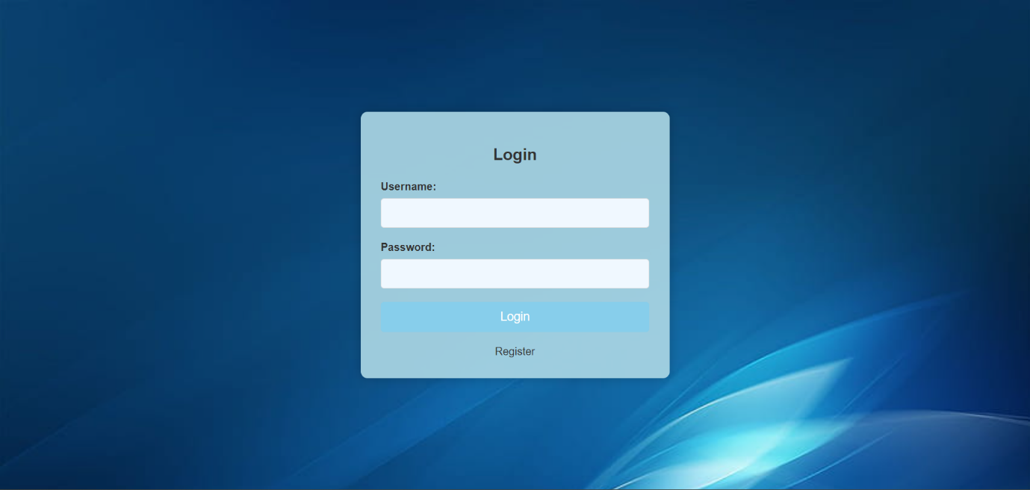

**8.3 Home Page:**

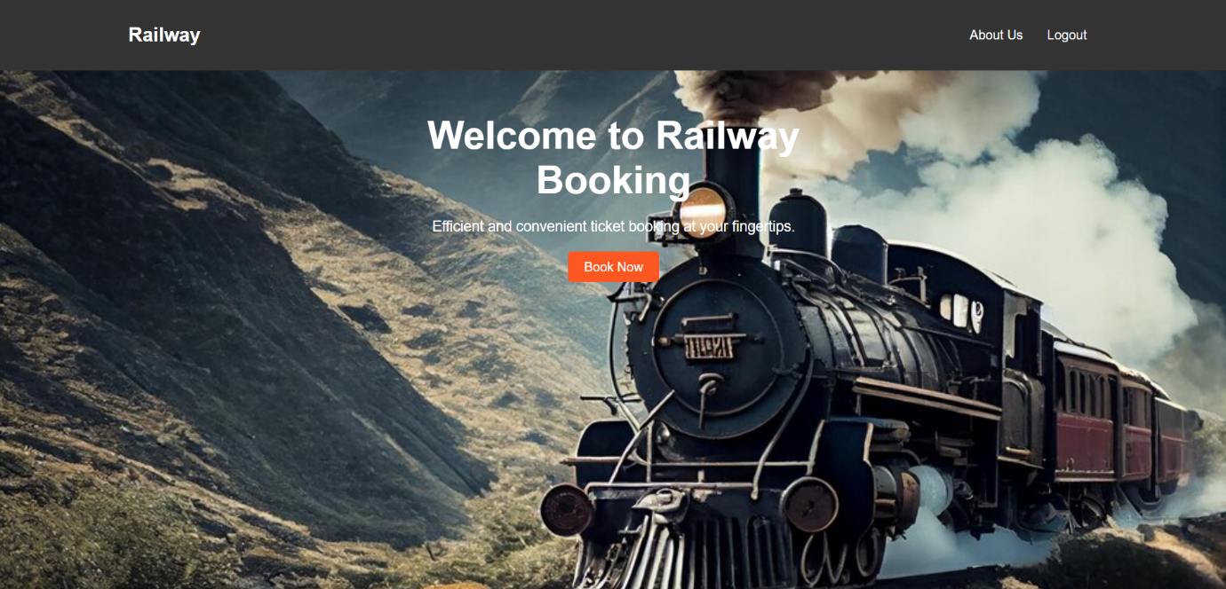

**8.4 About Us:**

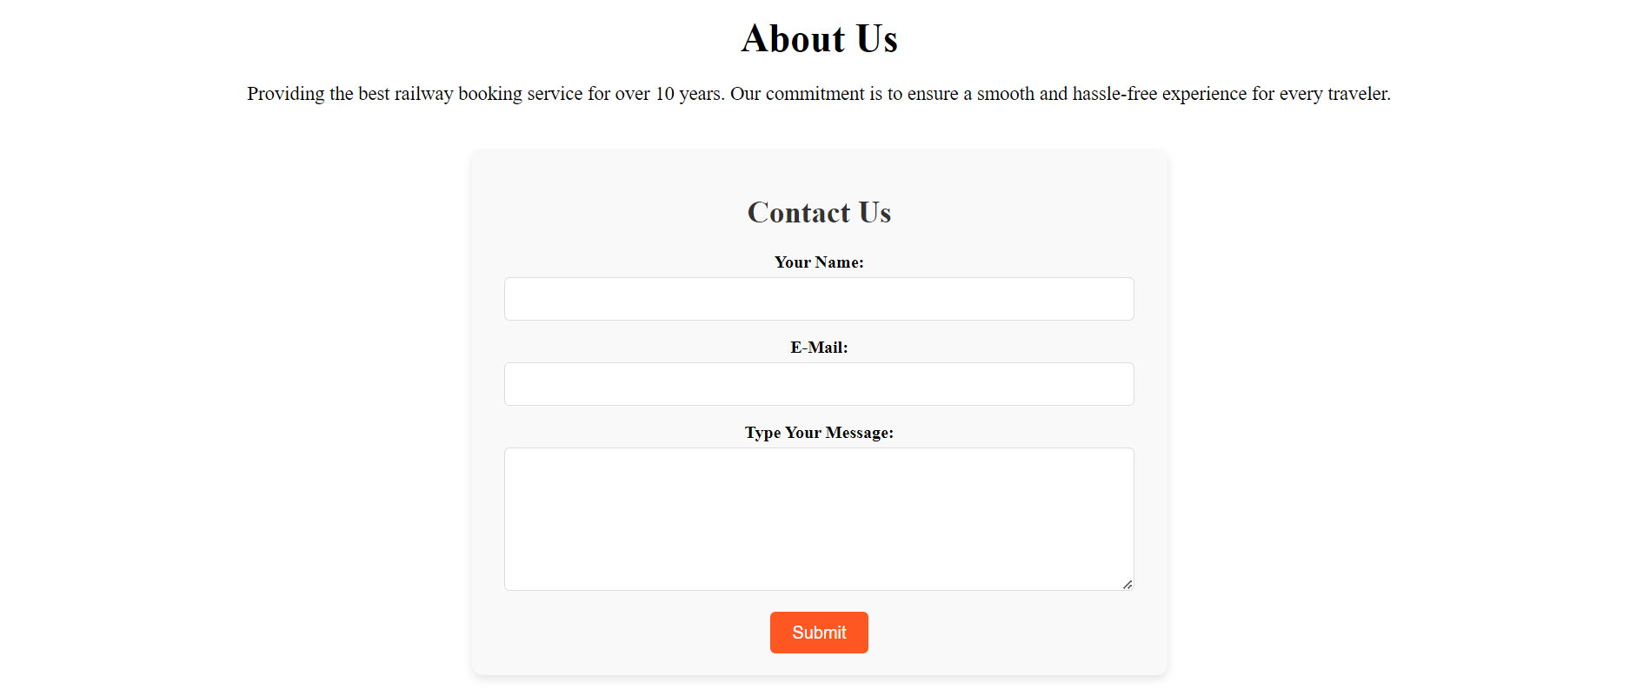

**8.5 Booking Form:**

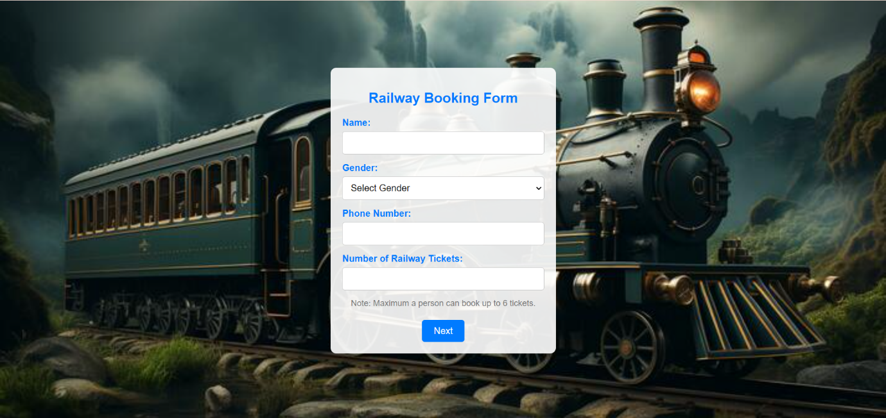

**8.5.1 Passenger Details:**

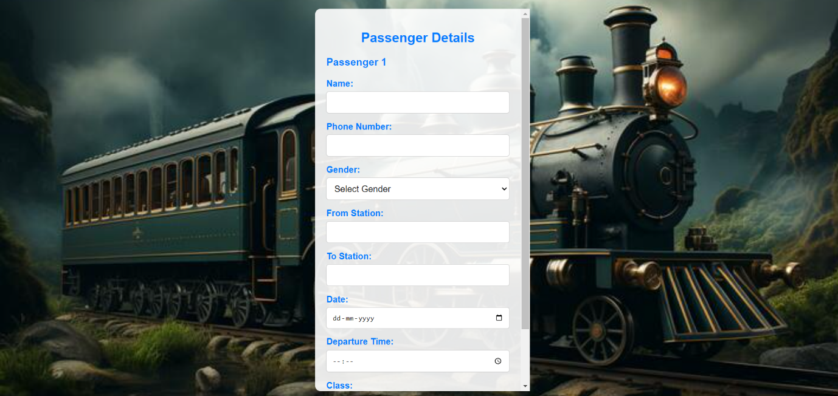

**8.6 Payment Form:**

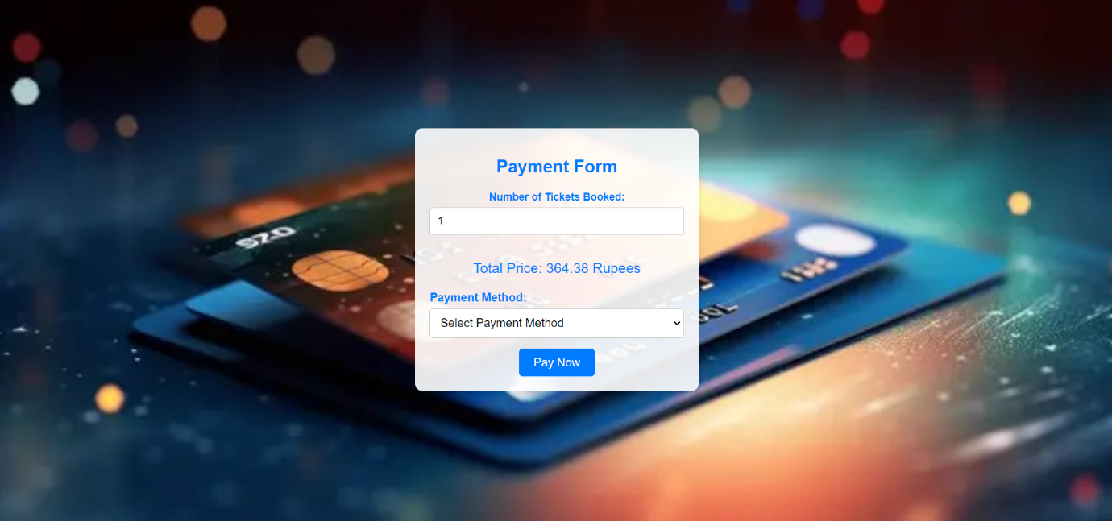

**8.6.1 Payment Method:**

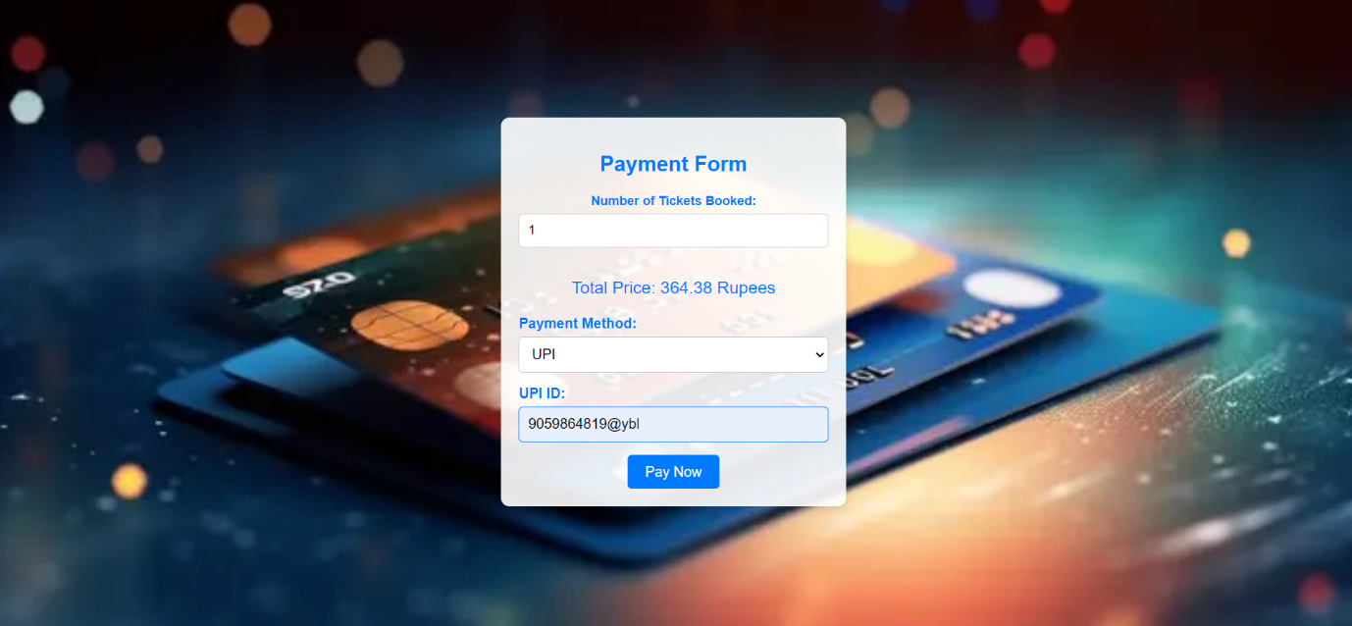

**8.7 Ticket Confirmation Form:**

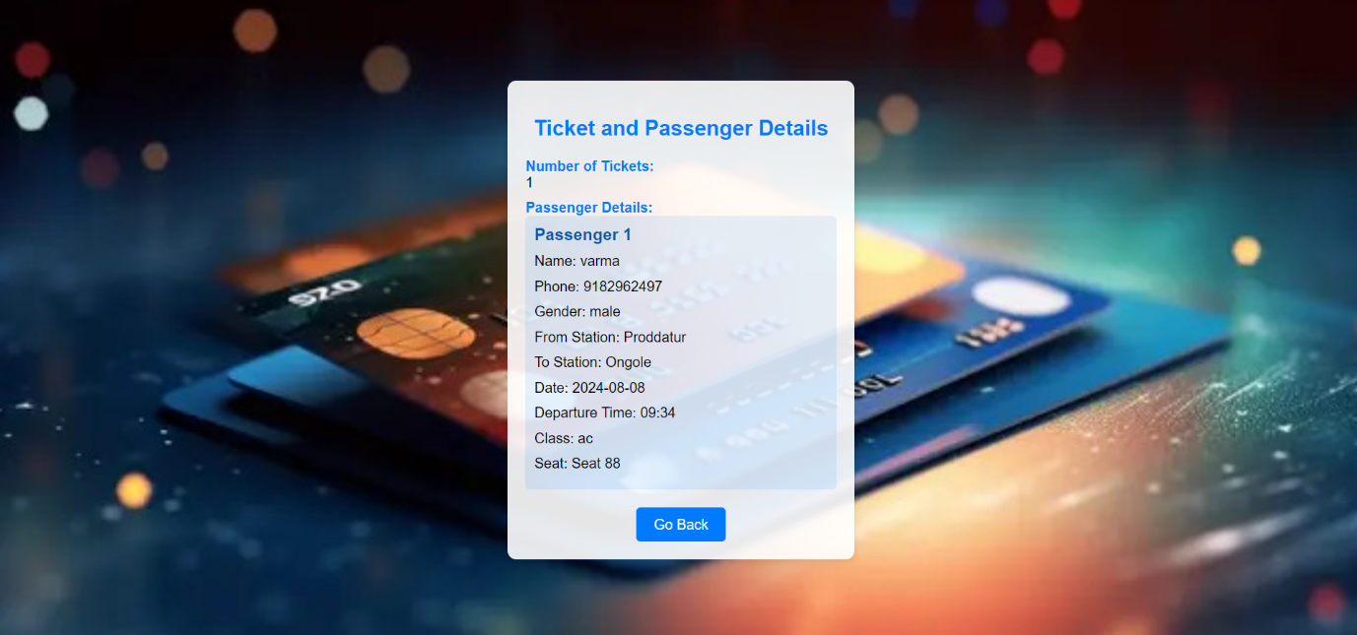

**9.Conclusion**

“The Railway Reservation System” represents a transformative approach to managing train bookings and schedules efficiently. By integrating comprehensive modules for user management, train schedules, seat and quota management, and booking and cancellation processes, the system ensures a streamlined and user-friendly experience. Administrators benefit from robust tools for monitoring transactions, generating detailed reports, and addressing customer support issues promptly. Enhanced security measures safeguard user data and ensure compliance with regulatory standards. Real-time updates and notifications keep users informed, enhancing their overall satisfaction. This system not only optimizes operational efficiency but also significantly improves the reliability and convenience of railway services for passengers, establishing a high standard in the transportation industry.

### **9.1 Future Enhancements**

The Railway Reservation System can be significantly enhanced to meet future demands and improve user experience. Integrating AI and machine learning will enable predictive analytics, optimizing seat allocations and predicting booking trends. Implementing blockchain technology will enhance security and transparency in transactions. Expanding mobile app functionalities will offer greater convenience, allowing users to book, modify, and track reservations on the go. Multilingual support will cater to a diverse user base, breaking language barriers and improving accessibility. Introducing a loyalty program can incentivize frequent travellers, fostering customer loyalty. Real-time train tracking and live updates will aid users in planning their journeys more effectively. Integrating with other transport modes, such as buses and taxis, can offer seamless multi-modal travel solutions. Offering virtual tours of train layouts will help users make informed seat selections. Automated customer support using chatbots can provide instant assistance, improving response times. Personalized travel recommendations based on user preferences can enhance the overall user experience.

Implementing contactless payment options will improve transaction efficiency and safety. Tracking the environmental impact of travel choices can promote eco-friendly options, aligning with sustainability goals. Advanced data analytics will provide deeper insights into user behaviour and system performance, guiding better decision-making. Collaborating with tourism services can offer comprehensive travel packages, adding value to users. Enhancing system scalability and performance will ensure it can handle increased user demand and future growth. Additionally, features like seat occupancy heatmaps, enhanced security protocols, and dynamic fare management can further streamline operations. By focusing on these enhancements, the Railway Reservation System can become more innovative, efficient, and user-friendly, setting new standards in the transportation industry and ensuring a superior travel experience for all passengers.

**References**

1. Srivastava, S. C., Mathur, S. S., & Teo, T. S. (2007). Modernization of passenger reservation system: Indian Railways’ dilemma. *Journal of Information Technology*, *22*(4), 432-439.
2. Mugira, Richard, and Daniel Okiror. "Design of an electronic railway ticket reservation system for rift valley railways." (2015).
3. Mallikarjuna, B., Reddy, D.A.K. and Sailaja, G., 2018, January. Enhancement of Railway Reservation System Using Internet of Things. In *Proceedings of the 1st International Conference Universal Computing, Communication in Data Engineering (CCODE-2018)* (Vol. 2).
4. Acharya K. Online bus reservation system project report. Authorea Preprints. 2024 Mar 21.
5. Ganti, Sailaja. "Enhancement of railway reservation system using internet of things." (2018).
6. Rani, S. Jhansi, and M. Pandiya Rajan. "Finger print based railway ticket reservation system using microcontroller." *International Research Journal of Engineering and Technology (IRJET)* 5, no. 5 (2018): 2070-2073.
7. Raman, K. S., & Wig, S. (2010). Risk Management in Large Information Systems (IS) Projects: A Case Study of the Indian Railways Computerized Passenger Reservation system. *ASCI Journal of management*, *39*(1), 33-54.
8. Ahmed RU, Happy MH, Roy SS. Android Based Railway Reservation System.
9. Mitev, Nathalie N. "More than a failure? The computerized reservation systems at French Railways." *Information Technology & People* 9, no. 4 (1996): 8-19.
10. Udawatta, U.K.D.D.P., 2013. *Web based mobile ticket reservation system for Public Transport in Sri Lanka Railway* (Doctoral dissertation).